Introduction to Packet Sniffing

Introduction to Packet Sniffing

The basic tool for observing the messages exchanged between executing protocol entities is called a **packet sniffer**. As the name suggests, a packet sniffer captures ("sniffs”) messages being sent/received from/by your computer; it will also typically store and/or display the contents of the various protocol fields in these captured messages. A packet sniffer itself is passive. It observes messages being sent and received by applications and protocols running on your computer, but never sends packets itself. Similarly, received packets are never explicitly addressed to the packet sniffer. Instead, a packet sniffer receives a *copy*of packets that are sent/received from/by application and protocols executing on your machine.

Figure 1 shows the structure of a packet sniffer. At the right of Figure 1 are the protocols (in this case, Internet protocols) and applications (such as a web browser or ftp client) that normally run on your computer. The packet sniffer, shown within the dashed rectangle in Figure 1 is an addition to the usual software in your computer, and consists of two parts. The **packet capture library**receives a copy of every link-layer frame that is sent from or received by your computer. Recall that messages exchanged by higher layer protocols such as HTTP, FTP, TCP, UDP, DNS, or IP all are eventually encapsulated in link-layer frames that are transmitted over physical media such as an Ethernet cable. In Figure 1, the assumed physical media is an Ethernet, and so all upper-layer protocols are eventually encapsulated within an Ethernet frame. Capturing all link-layer frames thus gives you all messages sent/received from/by all protocols and applications executing in your computer.

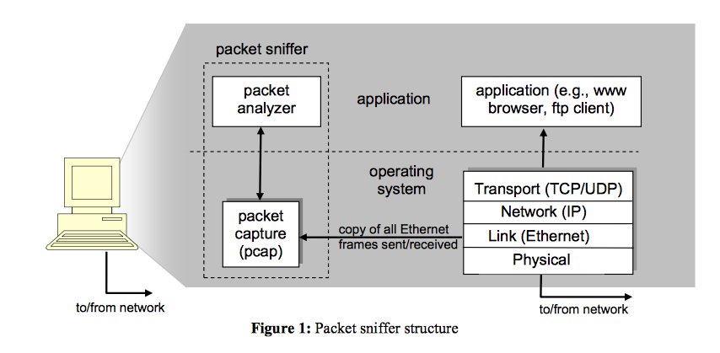

The second component of a packet sniffer is the **packet analyzer**, which displays the contents of all fields within a protocol message. In order to do so, the packet analyzer must "understand” the structure of all messages exchanged by protocols. For example, suppose we are interested in displaying the various fields in messages exchanged by the HTTP protocol in Figure 1 (above). The packet analyzer understands the format of Ethernet frames, and so can identify the IP datagram within an Ethernet frame. It also understands the IP datagram format, so that it can extract the TCP segment within the IP datagram. Finally, it understands the TCP segment structure, so it can extract the HTTP message contained in the TCP segment. Finally, it understands the HTTP protocol and so, for example, knows that the first bytes of an HTTP message will contain the string "GET,” "POST,” or "HEAD”.

We will be using the Wireshark packet sniffer [http://www.wireshark.org/] for this lab, allowing us to display the contents of messages being sent/received from/by protocols at different levels of the protocol stack. (Technically speaking, Wireshark is a packet analyzer that uses a packet capture library in your computer). Wireshark is a free network protocol analyzer that runs on Windows, Linux/Unix, and Mac computers. It's an ideal packet analyzer for our labs - it is stable, has a large user base and well-documented support that includes a user-guide (http://www.wireshark.org/docs/wsug_html_chunked/), man pages (http://www.wireshark.org/docs/man-pages/), and a detailed FAQ (http://www.wireshark.org/faq.html), rich functionality that includes the capability to analyze hundreds of protocols, and a well-designed user interface. It operates in computers using Ethernet, serial (PPP and SLIP), 802.11 wireless LANs, and many other link-layer technologies (if the OS on which it's running allows Wireshark to do so)